**SQL DATABASE**

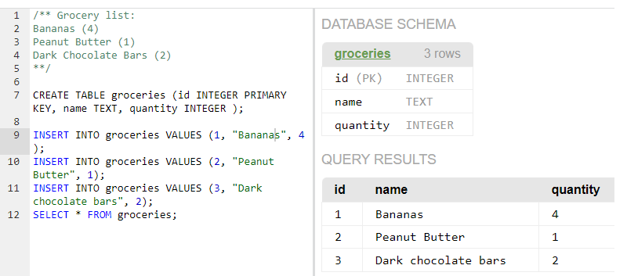{ Insert introduction here }

Penjelasan:  
CREATE TABLE {table name} ({every column which is separated by coma})

detail of ({every column...}) :

({value data-type key-to-access-row}, {value data-type key-to-access-row}, {value data-type key-to-access-row})

**What we learned**:

HAVING is conditional for the grouped values (having harus diletakan setelah GROUP BY)

WHERE is conditional for the individual value

ORDER BY

GROUP BY

SUM()/MAX()/AVG()

AND/OR

IN : to replace ... OR ... OR ... OR ...

AS

COUNT(*)